UMB ICTR
molecules to communities

ICTR ENRICHMENT SERIES
Tuesday, March 12, 2024 - 12:00 pm – 1:00 pm

PLEASE REGISTER FOR THIS ZOOM WEBINAR

https://us02web.zoom.us/webinar/register/WN_Hafc6rDnRT-cu4fOqHT_IA
“Walking the fine line between Human Subjects Research and Non-Human Subjects Research (NHSR) when engaging the community in research”

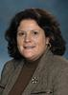
Presented by
Julie Doherty, DM, MSN, RN, CIP, CCEP Assistant Vice President, Research Compliance Office of Accountability & Compliance University of Maryland Baltimore

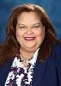
Jan E. Martinez, MS, CIP, CLSSGB (she/her)
IRB Manager
UMB OAC/HRPO/IRB
University of Maryland, Baltimore

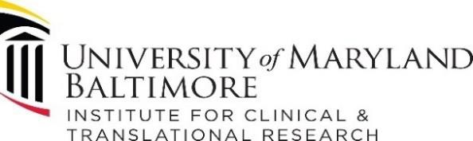
With theincreased in community-engaged research (CEnR) involving patients and community members as advisors versus “human subjects,” the line between Human Subjects Research and Non -Human Subjects Research (NHSR) is sometimes blurred. Moreover, many CEnR studies haveboth a NHSR phase (e.g. planning with Advisory Board) and a subsequent investigational phases during which a full IRB protocol for Human Subjects Research is needed. This session is a great opportunity for researchers to learn about the nuances of when community members are advisors vs. human subjects in research.

For more information, please contact:
410-328-2488 | ICTR-Navigator@umaryland.edu

