All Links
The All Links page allows you to access a large assortment of links which include common lookups for Sponsors, Organizations, and Address Book tables. This page can be used to access the Kuali Research module links (also found on the Common Tasks page). All of the links are organized by category and contained in expandable panels. While all links are visible to every user only users with authorized access will be able to view and edit certain records.
If you have an idea of what you are looking for the easiest option may be to be to simply type a keyword into the “Search for a Link” field. It will auto-populate results based on the text you enter.
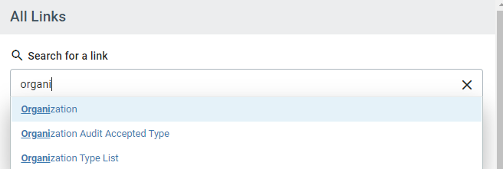

Quick Tip!
To access these common lookup tables simply type in their names in the “Search for a Link” field.
These are located under the Shared Across Modules and System Admin Panels.
- Sponsor
- Organization
- Address Book
Link Panels
Look for a link manually within each panel using the Category title as a guide.
- To expand each panel and display the links click on the down icon .
- To collapse each panel and hide links in that section click on the up icon .
- You will notice as you expand each additional section that previous section you opened will automatically be collapsed.

Common Links
Award
- All My Awards - Initiates a full search of awards where you are listed as the PI, CO-I or Key Person.
- Search Awards - Allows you to use the Full Search page to search for Award records.

Institutional Proposal
- Search Institutional Proposals - Allows you to use the Full Search page to search for Institutional Proposal records.

Miscellaneous
- Action List - Allows you to view your Action List where you will find requests for approval, proposal certification requests, FYIs, and other items.
- Current & Pending Support - Allows you to do a Current or Pending Report for any investigator. After selecting a person, click “Initiate Report” then you may select an Export option at the bottom. You may alternatively select the “Print” option to generate a PDF of each.
- Doc Search - Allows you to search for any record by the document number.
- Locks - Allows you to search for your Pessimistic Locks.
- Sponsor - Allows you to search the Sponsor lookup table.
- Unit - Allows you to search for any unit number/name.
- Unit Hierarchy - Allows you to view the unit organization among departments and schools.

Proposal Development
- All My Proposals - Initiates a full search of Proposal Development records where you are listed as a Participant (person listed in the Access section of a Prop Dev record). This can help proposal creators to identify proposals they’ve initiated. However, other searches may be more useful (Principal ID is the 8-digit number associated with your login):
  - To find proposals where you are a PI, CO-I, or Key Person, enter your Principal ID in the “Proposal Person” search field.
  - To find proposal where you are a PI (or Multi-PI), enter your Principal ID in the Principal Investigator field.
  - To find proposal where you are the initiator (proposal creator), enter your Principal ID in the “Initiator Username” search field.
- Create Proposal - Allows you to create a Proposal Development record (for users with Proposal Creator user roles in Kuali Research).
- Proposals Enroute - Allows you to perform a search for Prop Dev records that have been submitted into the review/approval process (Approval in Progress, Approval Pending, etc.)
- Search Proposals - Allows you to use the Full Search page to search for Prop Dev records.

Shared Across Modules
- Address Book - Allows you to search the Address Book (non-UMB employees, sponsor contacts, performance sites)
- Organization - Allows you to search the Organization (aka subrecipient) lookup.

Subaward
- Search Subawards - Allows you to use the Full Search page to search for Subaward records.

System Admin
- Organization - Allows you to search the Organization (aka subrecipient) lookup.
- Pessimistic Locks - Allows you to search for your Pessimistic Locks.
- Sponsor - Allows you to search the Sponsor lookup.

